ANALOG ELECTRONICS / LTspice SIMULATION
SINGLE-STAGE COMMON-EMITTER BJT AMPLIFIER
DESIGN AND SIMULATION REPORT

Voltage-Divider Biased Common-Emitter Amplifier

Supply Voltage: 12 V | Transistor: 2N2222
RC = 2.2 kΩ | RE = 1 kΩ | RL = 10 kΩ
RS = 600 Ω | β = 100 | Input = 30 mV, 1 kHz

Name:s.hari prasath
Reg no: 192512041

1. AIM
To design and simulate a single-stage common-emitter BJT amplifier using a voltage-divider bias network in LTspice, with a 12 V supply, and to observe the input and output waveforms and amplifier response.

2. APPARATUS / SOFTWARE REQUIRED
- Computer or laptop with LTspice installed.
- 2N2222 NPN BJT transistor model.
- DC supply of 12 V.
- Resistors: R1 = 330 kΩ, R2 = 33 kΩ, RC = 2.2 kΩ, RE = 1 kΩ, RL = 10 kΩ.
- Capacitors: C1 = 2.2 µF, C2 = 1 µF, CE = 22 µF.
- AC signal source: SINE(0 0.03 1000), i.e. 30 mV peak at 1 kHz.
- LTspice transient analysis.

3. DESIGN SPECIFICATIONS
Parameter | Specification
Supply voltage, VCC | 12 V
Collector resistor, RC | 2.2 kΩ
Emitter resistor, RE | 1 kΩ
Load resistance, RL | 10 kΩ
Source resistance, RS | 600 Ω
Transistor current gain, β | 100
Required mid-band voltage gain | Approximately 20 V/V
Required lower cutoff frequency | Approximately 100 Hz

4. METHODOLOGY
- Select a 2N2222 NPN transistor in common-emitter configuration.
- Use R1 and R2 as a voltage-divider network to establish the base bias voltage.
- Use RC as the collector resistor and RE as the emitter resistor for DC stabilization.
- Use CE as the emitter bypass capacitor to increase AC voltage gain in the mid-band region.
- Use C1 as the input coupling capacitor and C2 as the output coupling capacitor to block DC.
- Connect the 10 kΩ load through C2 at the output.
- Apply a 30 mV peak, 1 kHz sinusoidal input through the 600 Ω source resistance.
- Run a transient simulation and observe the output waveform at the node marked 'out'.

5. PROCEDURE
1. Open LTspice and create a new schematic.
2. Place a 2N2222 NPN transistor and connect it in common-emitter configuration.
3. Connect RC = 2.2 kΩ from VCC = 12 V to the collector.
4. Connect RE = 1 kΩ from the emitter to ground.
5. Connect CE = 22 µF in parallel with RE.
6. Connect R1 = 330 kΩ from VCC to the base and R2 = 33 kΩ from the base to ground.
7. Connect the input source through RS = 600 Ω and C1 = 2.2 µF to the transistor base.
8. Connect C2 = 1 µF from the collector to RL = 10 kΩ, and mark the far end as 'out'.
9. Set the source to SINE(0 0.03 1000).
10. Set the transient analysis to .tran 0 10m 1m 100k (as shown in the supplied LTspice schematic).
11. Run the simulation and plot the output voltage V(out).
12. Compare the observed waveform with the applied input and evaluate the amplifier operation.

6. CIRCUIT DIAGRAM
The following is the original LTspice circuit image supplied for the experiment. It is inserted without modification.
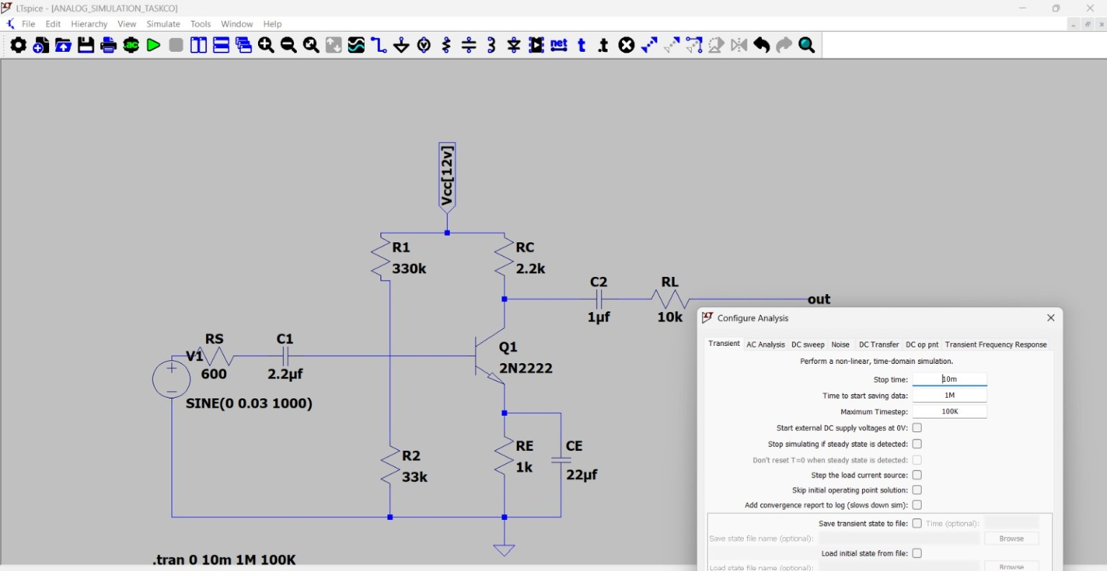
Figure 1: LTspice common-emitter BJT amplifier circuit

7. INPUT IMAGE / INPUT SIGNAL
The input source used in the supplied schematic is SINE(0 0.03 1000), corresponding to a 30 mV peak sinusoidal signal at 1 kHz, applied through the 600 Ω source resistance.
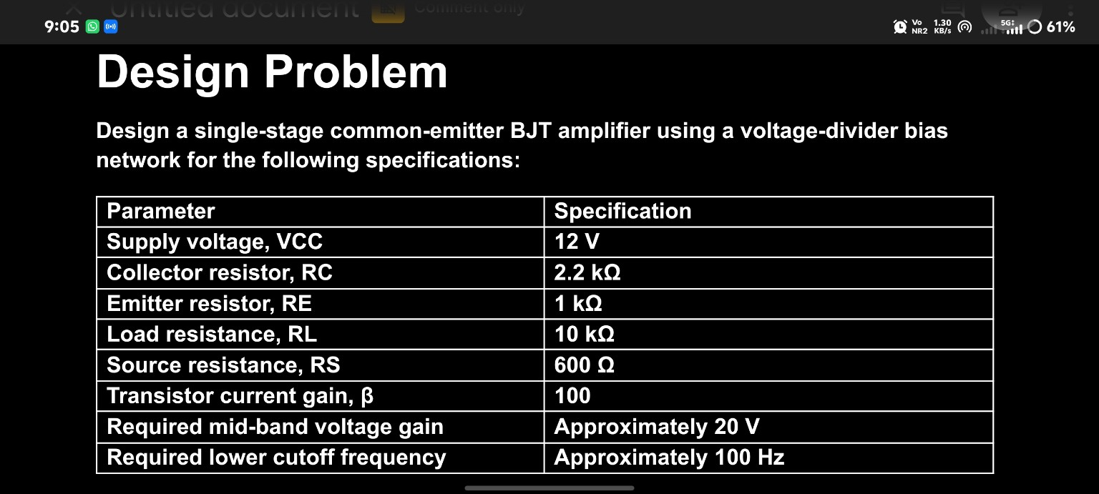
Figure 2: Original supplied design specification image

8. OUTPUT IMAGE
The following is the original LTspice simulation waveform supplied. The plotted trace is V(out). No changes have been made to the image.
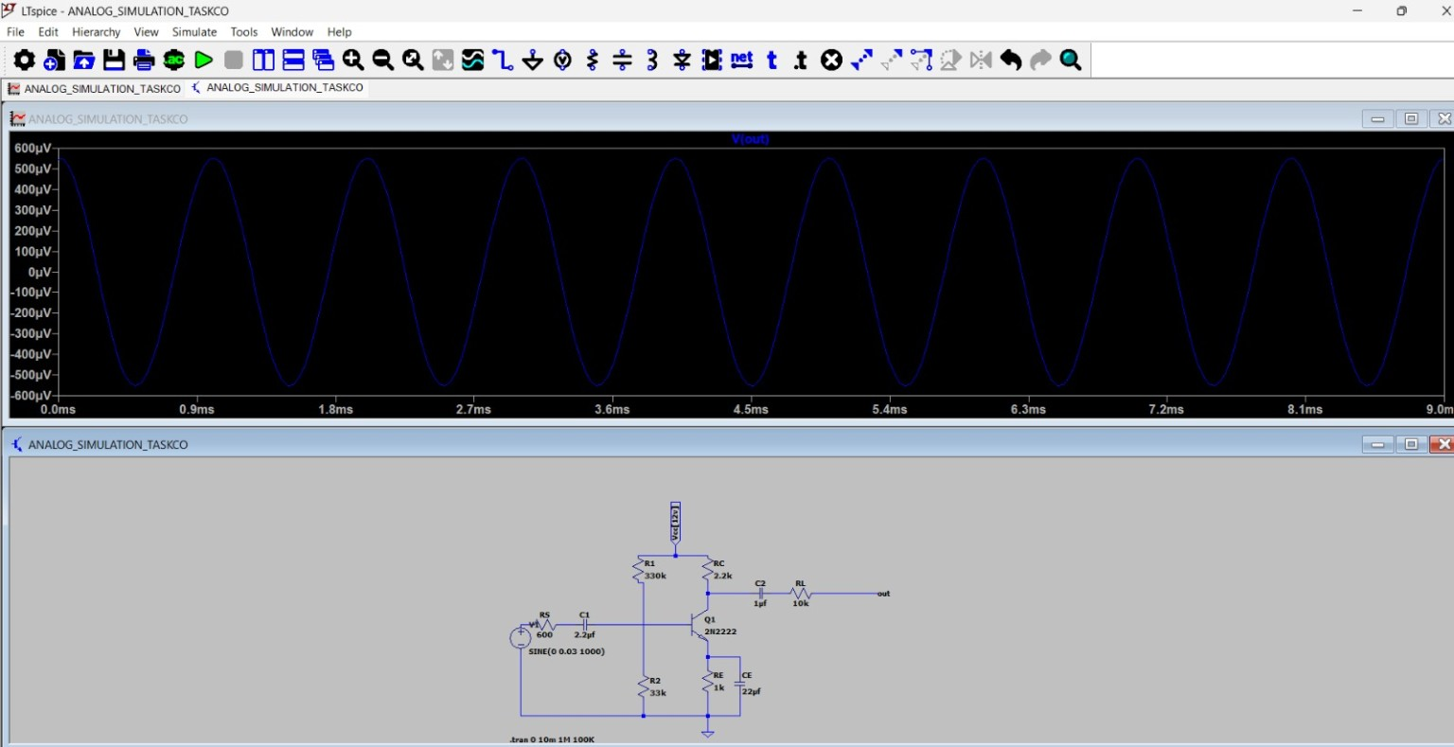
Figure 3: Original supplied LTspice output waveform V(out)

9. INPUT IMAGE
The following additional supplied screenshot is included exactly as provided to preserve the complete simulation evidence.
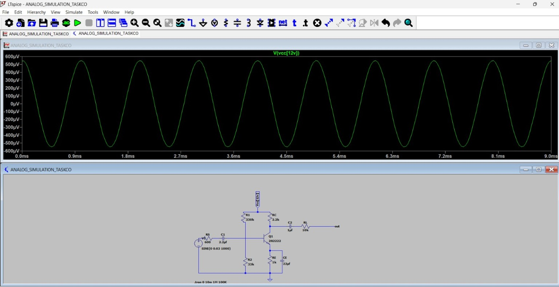
Figure 4: Original supplied LTspice simulation screenshot

10. OBSERVATION
- The circuit is a voltage-divider biased, single-stage common-emitter BJT amplifier.
- The input source is a 1 kHz sinusoid with 30 mV peak amplitude.
- The output waveform shown in the supplied LTspice result is periodic and sinusoidal.
- The output is phase-inverted with respect to the input, as expected from a common-emitter stage.
- The supplied output plot is displayed in the microvolt range; therefore, the displayed simulation result should be checked against the intended probe node, transistor model, and bias point if a gain of approximately 20 V/V is required.

11. RESULT
A single-stage voltage-divider biased common-emitter BJT amplifier was designed and simulated in LTspice using the specified component values. The supplied simulation produces a sinusoidal output waveform at 1 kHz. The circuit topology and component values match the stated design specifications. However, the supplied V(out) waveform is only in the microvolt range, so the simulated voltage gain does not demonstrate the specified approximately 20 V/V gain. The biasing, transistor model, output-node connection, and measurement setup should therefore be verified before considering the gain specification satisfied.

12. CONCLUSION
The common-emitter BJT amplifier was successfully constructed in LTspice according to the given design. The transient simulation and output waveform were obtained. The supplied images are retained without alteration. The observed output level indicates that further verification of the LTspice circuit and operating point is needed to achieve the required mid-band voltage gain of approximately 20 V/V and the intended lower cutoff frequency of approximately 100 Hz.

